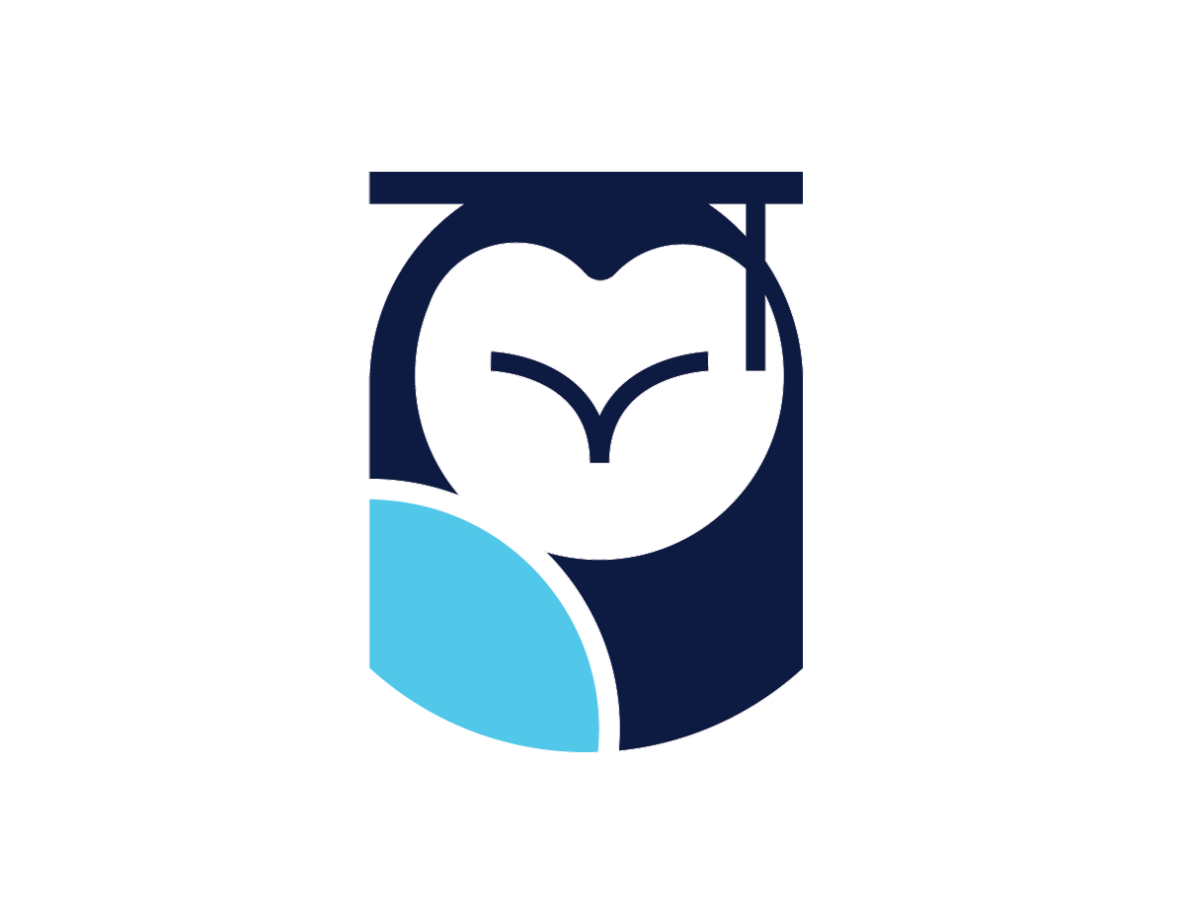  M/J Visual Art 1  Optima Academy Online · Course Syllabus · 2026–2027 | Full Year  Grade 6

FOR THE TEACHER — make this syllabus yours, then delete this box. (1) Replace every yellow-highlighted field with your own information: your name, your email, and your office hours. (2) Adjust any dates your section changes. (3) Delete this instruction box. (4) Save, then export as a PDF (File > Save As > PDF) or paste the content into your Canvas Syllabus page. Everything else — grading, policies, and module structure — is fixed for all sections of this course and should not be edited.

Facilitator  [Your full name] | Email & Office  [your.email@optimaed.com] · 239.673.2801 (OAO Front Office)
Florida Course  Florida 0101100 · Full-year course | Office Hours  [Your office hours — day, time, and where to find you]
Grade Level  Grade 6 (Middle School) | Format  On-Demand (also offered live on the VR campus)

About this syllabus. This is the plan for the course as designed. It is a full-year middle-school course; On-Demand scholars pace through the nineteen two-week modules across the four quarters of their enrolled year. On-Demand and live-school sections share the same content and expectations; exact pacing, scheduled dates, and a few activities may vary from section to section and term to term. Your facilitator will confirm the specifics for your section.
Course Overview
M/J Visual Art 1 is a year-long journey through world art, made with the scholar's own hands. The course opens with the seven Elements of Art, the building blocks every artist uses, and then travels the world: the woodblock prints of Edo-period Japan, the painted caves of prehistory, ancient Egypt, Greece, and Rome, the masks and landscapes of Africa, the mandalas and architecture of India, the pagodas and porcelain of China, Aboriginal Australian dot painting, and the totem poles, glyphs, and sun stones of the Americas.
Every module is a two-week studio cycle. Scholars study a real masterwork up close, practice its key move in a low-stakes sketch, step into a VR gallery to look at and talk about art, take a short quiz, and then make a finished artwork of their own, signed, photographed, and submitted with a short artist statement in their own voice. Each finished piece joins a growing digital portfolio, and in the final module scholars become curators, selecting, arranging, and labeling a year of their own work in their own World Art Museum.
What scholars will learn to do
• Use all seven Elements of Art (line, shape, form, color, value, texture, space) and the Principles of Design deliberately in original artworks.
• Look long and carefully at masterworks and critique them in order: describe, analyze, interpret, judge.
• Connect artworks to the cultures, times, and places that made them, from prehistoric caves to Edo-period Japan to the Aztec Empire.
• Practice studio skills in home-accessible media: drawing, shading, outlining, pattern, and careful color.
• Write artist statements in their own voice, using accurate art vocabulary to explain their choices.
• Build and maintain a year-long digital art portfolio in OneDrive.
• Practice exhibition etiquette and experience art at scale in weekly VR gallery walks.
• Curate a museum: select, arrange, label, and present a year of their own work.
Big Projects & Milestones
The course builds toward a body of finished, signed artwork. Target dates below follow a sample full-year pacing; On-Demand scholars pace to their own enrolled term and Live sections follow the class schedule, keeping each milestone roughly in order.
Project / Milestone | Course Place | Sample Target | What You Turn In
An Artwork + Artist Statement | Every module · one per 2-week cycle | Ongoing, all year | A finished, signed artwork (photographed and uploaded in Canvas) with a 1–2 sentence artist statement, graded on the studio rubric.
The Art Portfolio | All year · OneDrive | Grows every module | A saved copy of every finished artwork, consistently named (VisualArt1_M#_Artwork_YourName). The end-of-year capstone is built from it.
The World Art Museum (course capstone) | Module 19 · end of Quarter 4 | by May 21 | A curated exhibition of the year's work: pieces selected and arranged (in VR or as a slideshow), museum labels written, and a Curator's Statement.
Important Dates — 2026–2027
Aug 12, 2026 | First day of school | Sep 7 | Holiday (Labor Day)
Oct 9 | Quarter 1 ends | Oct 12 | Holiday (Columbus Day)
Nov 11 | Holiday (Veterans' Day) | Nov 23–27 | Thanksgiving break
Dec 18 | Quarter 2 ends · fall semester ends | Dec 21–Jan 1 | Winter break
Jan 5, 2027 | Classes resume | Jan 18 | Holiday (MLK Day)
Feb 15 | Holiday (Presidents' Day) | Mar 5 | Quarter 3 ends
Mar 26–Apr 5 | Spring break | Apr 6 | Classes resume
May 28, 2027 | Quarter 4 ends · last day of school | May 31 | Holiday (Memorial Day)
Assessment & Grading
76%  Artworks & artist statements (the graded studio project in every module, including the capstone) | 8%  Sketch practice (one low-stakes practice sketch per module, completion-scored) | 8%  VR gallery sessions (one per module, completion-scored) | 8%  Module quizzes (short auto-graded checks on the module's art and vocabulary)
Percentages reflect the course's point structure: each regular module carries a 100-point artwork plus three 10-point practice items (sketch, VR session, quiz). The Module 19 capstone carries heavier planning and gallery items.
How This Course Is Delivered
This course is offered in two formats that share the same content, assignments, and expectations: an On-Demand (asynchronous) section you pace yourself, and a Live (synchronous) section that meets on a schedule on Optima's VR campus. The two overviews below explain how each one works. Find the one that matches your enrollment.
On-Demand (Asynchronous) Learning
In the On-Demand section you move through the course at your own pace within each quarter, guided by due dates that keep you on track. All assignments for a quarter open at its start and close at its end. Because the course is On-Demand, there is no grade penalty for missing an individual due date, but any assignment not completed by the end of the quarter receives a zero, and assignments submitted in the final 14 days of a quarter receive a 10% deduction, so steady pacing matters.
Attendance is measured by assignment completion. Per school policy, a scholar who completes no assignment for ten consecutive school days, without notifying the school of an absence in advance, may be dropped from the course. Completion means a sincere attempt, real effort on real work. Rushed work, wrong or corrupted files, irrelevant or nonsense submissions, AI-generated filler, and word-salad responses do not count.
You are never on your own. A live facilitator grades your work, gives feedback, and hosts a weekly study hall and VR workshops.
Live (Synchronous) Learning
In the Live section you join scheduled class meetings on Optima's VR campus, where your teacher leads instruction in real time and you learn alongside classmates. The lessons, assignments, and projects are the same as the On-Demand course; what differs is the pacing. A Live section moves through the material together on the class schedule rather than at each scholar's own pace, and class time is also used for discussion, questions, and guided studio practice.
Attendance is measured by presence and participation. You are expected to attend the scheduled live sessions, on time and ready to take part. If you must miss a class, notify the school in advance; your teacher will let you know how to make up the work and any material you missed. As in every Optima course, completing your work means a sincere attempt, real effort on real work, and assignments still open and close with each quarter.
You meet regularly with a teacher. The class gathers throughout the week in VR and on Microsoft Teams for live instruction and discussion.
Appropriate Use of AI
Optima scholars are preparing for a world shaped by artificial intelligence, and learning to use these tools with good judgment is part of that preparation. You are welcome to use AI tools to support your learning, to explain a concept a different way, check your understanding, or brainstorm, unless a particular assignment says otherwise. What AI may never do is the thinking or the work an assignment asks of you: your sketches, your artworks, and your artist statements must be genuinely your own. Submitting AI-generated work or text as if it were your own is dishonest and, as noted above, counts as an insincere attempt. When you do use an AI tool on an assignment, say so briefly. Above all, build the underlying skill yourself. The goal is for you to be able to judge whether an AI's answer is any good, which you can only do if you can do the work without it.
Learning in Virtual Reality
Optima is a virtual-reality school. Alongside your Canvas coursework, you will join immersive sessions on Optima's VR campus, where you meet teachers and fellow scholars, take part in live activities, and explore places and ideas you could not visit in an ordinary classroom. In this course that means gallery walks among great artworks and quick create-in-VR activities. Keep your headset charged and ready for any scheduled VR sessions, and treat the VR campus with the same courtesy and seriousness you would a physical one. If you ever cannot get into VR for a session, tell your facilitator; there is an alternative way to take part so you do not fall behind.
Being an Optima Scholar
Optima's mission is an excellent, virtue-centered education, and virtue is at the center of this course as much as any other. Every scholar is expected to practice the seven virtues that shape life at Optima: courage, courtesy, honesty, perseverance, self-government, service, and responsibility. In practice that means: do your own honest work and sign it; treat everyone you meet in, through, or because of this course with respect, in writing, in discussion, and in VR; engage actively rather than passively; come to office hours to get help, meet other scholars, and get to know your facilitator; and take responsibility for your own pacing and progress. You belong to a house and a community of scholars, not only to a course.
What You Need & Staying Connected
✔ A computer with reliable internet and access to Canvas.
✔ A VR headset, charged and ready for the gallery sessions on Optima's VR campus.
✔ A basic home art kit: drawing paper, pencils and an eraser, a black marker or pen for outlining, and coloring tools (colored pencils, crayons, or markers).
✔ Microsoft 365 with OneDrive, for the digital art portfolio you build all year.
✔ A sketchbook or notebook for practice sketches, notes, and vocabulary.
Staying connected. Updates about this course are posted on the course's Canvas page; school-wide updates are posted in your Homeroom Canvas course. Check both regularly. Your facilitator holds office hours and is glad to help with the material, to meet you, or to talk through your plans. Come by, or reach out any time by email.
M/J Visual Art 1 · Florida course 0101100 · Full-year middle-school course · Optima Academy Online, 2026–2027. Built from the course content (19 modules of 2-week studio cycles, Modules 1–10 in Semester 1 and 11–19 in Semester 2) and the board-approved 2026–2027 academic calendar. On-Demand scholars pace to their own enrolled term. School calendar dates may be adjusted by the school.

